Exercises: SQLAlchemy
The following tasks do not require submissions to the Judge System.

Ask your questions here: https://www.slido.com by entering the course code #python-db

SQLAlchemy Setup [Solve with AI]

Model Recipe
Your task is to define a Python class, Recipe, which inherits from SQLAlchemy's Base class and represents the "recipes" table. The table should have the following columns:
- id (Primary Key):
  - Data Type: Integer
  - A unique identifier for each recipe.
- name:
  - Data Type: String
  - The name of the recipe. This field is required and must not be left empty.
- ingredients:
  - Data Type: Text
  - A field to store the list of ingredients for the recipe. This field is required and must not be left empty.
- instructions:
  - Data Type: Text
  - A field to store the cooking instructions for the recipe. This field is required and must not be left empty.

Create Recipe
Function: "create_recipe(name: str, ingredients: str, instructions: str)" creates a new recipe instance with the given arguments, adds it to the session, commits it, and returns it as a result.

Examples
name | ingredients | instructions
Spaghetti Carbonara | Pasta, Eggs, Pancetta, Cheese | Cook the pasta, mix it with eggs, pancetta, and cheese
Chicken Stir-Fry | Chicken, Bell Peppers, Soy Sauce, Vegetables | Stir-fry chicken and vegetables with soy sauce
Caesar Salad | Romaine Lettuce, Croutons, Caesar Dressing | Toss lettuce with dressing and top with croutons

Test Code
# Query all recipes
recipes = session.query(Recipe).all()
# Loop through each recipe and print its details
for recipe in recipes:
print(f"Recipe name: {recipe.name}")
Output
Recipe name: Spaghetti Carbonara
Recipe name: Chicken Stir-Fry
Recipe name: Caesar Salad

Update Recipe
Function: "update_recipe_by_name(name: str, new_name: str, new_ingredients: str, new_instructions: str)" updates the recipe by the given name with the new arguments, and commits the session.

Examples
Test Code
# Update a recipe by name
update_recipe_by_name(
name="Spaghetti Carbonara",
new_name="Carbonara Pasta",
new_ingredients="Pasta, Eggs, Guanciale, Cheese",
new_instructions="Cook the pasta, mix with eggs, guanciale, and cheese"
)
# Query the updated recipe
updated_recipe = session.query(Recipe).filter_by(name="Carbonara Pasta").first()
# Print the updated recipe details
print("Updated Recipe Details:")
print(f"Name: {updated_recipe.name}")
print(f"Ingredients: {updated_recipe.ingredients}")
print(f"Instructions: {updated_recipe.instructions}")
Output
Name: Carbonara Pasta
Ingredients: Pasta, Eggs, Guanciale, Cheese
Instructions: Cook the pasta, mix with eggs, guanciale, and cheese

Delete Recipe
Function: "delete_recipe_by_name(name: str)" deletes the recipe object with the given name and commits the session.

Examples
Test Code
# Delete a recipe by name
delete_recipe_by_name("Carbonara Pasta")
# Query all recipes
recipes = session.query(Recipe).all()
# Loop through each recipe and print its details
for recipe in recipes:
print(f"Recipe name: {recipe.name}")
Output
Recipe name: Chicken Stir-Fry
Recipe name: Caesar Salad

Filter Recipes
Function: "get_recipes_by_ingredient(ingredient_name: str)" returns all recipes that contain the specified ingredient name.
We'll be working with fresh instances, and it would be beneficial to start with a clean database.

Examples
Test Code
# Delete all objects (recipes) from the database
session.query(Recipe).delete()
session.commit()
# Create three Recipe instances with two of them sharing the same ingredient
recipe1 = create_recipe(
'Spaghetti Bolognese',
'Ground beef, tomatoes, pasta',
'Cook beef, add tomatoes, serve over pasta'
)
recipe2 = create_recipe(
'Chicken Alfredo',
'Chicken, fettuccine, Alfredo sauce',
'Cook chicken, boil pasta, mix with sauce'
)
recipe3 = create_recipe(
'Chicken Noodle Soup',
'Chicken, noodles, carrots',
'Boil chicken, add noodles, carrots'
)
# Run the function and print the results
ingredient_to_filter = 'Chicken'
filtered_recipes = get_recipes_by_ingredient('Chicken')
print(f"Recipes containing {ingredient_to_filter}:")
for recipe in filtered_recipes:
print(f"Recipe name - {recipe.name}")
Output
Recipes containing Chicken:
Recipe name - Chicken Alfredo
Recipe name - Chicken Noodle Soup

Recipe Ingredients Swap Transaction
Function: "swap_recipe_ingredients_by_name(first_recipe_name: str, second_recipe_name: str)" swaps the ingredients between the given recipes by their names. You must do this through transactions.
- First, start the transaction.
- Try to get the recipes (objects) by their name from the database. Then replace the ingredients between both recipes. Do not forget to commit the transaction.
- Except for an Exception if any error occurs during the process. If that's the case, initiate a transaction rollback and raise an Exception with the error message (not required).
- Finally, close the session.

Examples
Test Code
# Delete all objects (recipes) from the database
session.query(Recipe).delete()
session.commit()
# Create the first recipe
create_recipe("Pancakes", "Flour, Eggs, Milk", "Mix and cook on a griddle")
# Create the second recipe
create_recipe("Waffles", "Flour, Eggs, Milk, Baking Powder", "Mix and cook in a waffle iron")
# Now, swap their ingredients
swap_recipe_ingredients_by_name("Pancakes", "Waffles")
recipe1 = session.query(Recipe).filter_by(name="Pancakes").first()
recipe2 = session.query(Recipe).filter_by(name="Waffles").first()
print(f"Pancakes ingredients {recipe1.ingredients}")
print(f"Waffles ingredients {recipe2.ingredients}")
Output
Pancakes ingredients: Flour, Eggs, Milk, Baking Powder
Waffles ingredients: Flour, Eggs, Milk

Hint
To begin with, let us explain what a transaction is in SQLAlchemy. In the context of databases and database management systems, a transaction is a fundamental concept that ensures the integrity, consistency, and reliability of data. A transaction is a sequence of one or more database operations that are treated as a single, indivisible unit of work. These operations typically include data retrieval, insertion, updating, and deletion.
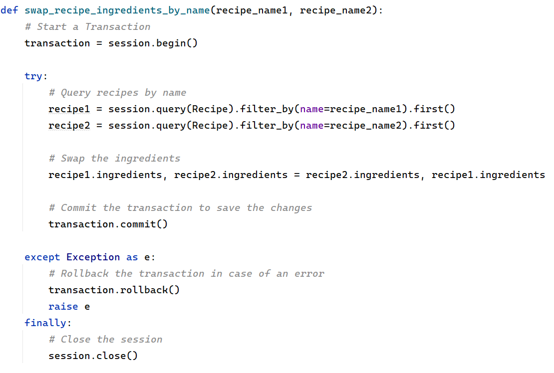

Model Chef
Your task is to define a Python class, Chef, which inherits from SQLAlchemy's Base class and represents the "chefs" table. The table should have the following columns:
- id (Primary Key):
  - Data Type: Integer
  - A unique identifier for each chef.
- name:
  - Data Type: String
  - The name of the chef. This field is required and must not be left empty.
- Recipes (Relationship to Recipe model):
  - Data Type: Relationship
  - Each chef can have multiple recipes. This is represented by a many-to-one relationship with the Recipe model. The recipes attribute allows you to access all the recipes created by a specific chef.
  - The back_populates attribute ensures bidirectional navigation. Set its value to "chef".

Extend the Recipe Model
You are going to add the following fields to the Recipe model:
- chef_id (Foreign Key):
  - Data Type: Integer
  - Description: A foreign key that establishes a relationship with the "Chef" model. It associates each recipe with a chef. This field is required and must not be left empty.
- chef (Relationship to Chef model):
  - Data Type: Relationship
  - Description: A relationship field connecting each recipe to a chef. This establishes the association that one chef can have multiple recipes and one recipe is owned by only one chef.
  - The back_populates attribute ensures bidirectional navigation. Set its value to "recipes".

Recipe and Chef Relations
Function: "relate_recipe_with_chef_by_name(recipe_name: str, chef_name: str)" creates a relation between the recipe and the chef, given by their names.
- If there is a relationship between the recipe and some chef, raise an Exception with the message: "Recipe: {recipe_name} already has a related chef".
- Otherwise, link the chef to the recipe, commit the session, and return a result: "Related recipe {recipe_name} with chef {chef_name}"

Examples
Test Code
# Create a recipe instance for Bulgarian Musaka
musaka_recipe = Recipe(
name="Musaka",
ingredients="Potatoes, Ground Meat, Onions, Eggs, Milk, Cheese, Spices",
instructions="Layer potatoes and meat mixture, pour egg and milk mixture on top, bake until golden brown."
)
# Create a Bulgarian chef instances
bulgarian_chef1 = Chef(name="Ivan Zvezdev")
bulgarian_chef2 = Chef(name="Uti Buchvarov")
# Add the recipe instance to the session
session.add(musaka_recipe)
# Add the chef instances to the session
session.add(bulgarian_chef1)
session.add(bulgarian_chef2)
# Commit the changes to the database
session.commit()
Test Code
print(relate_recipe_with_chef_by_name("Musaka", "Ivan Zvezdev"))
Output
Related recipe Musaka with chef Ivan Zvezdev
Test Code
print(relate_recipe_with_chef_by_name("Musaka", "Chef Uti"))
Output
Traceback (most recent call last):
File "C:\PyCharmProjects\Django ORM\10-SQLAlchemy\main.py", line 117, in <module>
print(relate_recipe_with_chef_by_name("Musaka", "Chef Uti"))
^^^^^^^^^^^^^^^^^^^^^^^^^^^^^^^^^^^^^^^^^^^^^^^^^^^^^
File "C:\PyCharmProjects\Django ORM\10-SQLAlchemy\main.py", line 81, in relate_recipe_with_chef_by_name
raise Exception(f'Recipe: {recipe_name} already has a related chef')
Exception: Recipe: Musaka already has a related chef

10. Chef and Recipe Integration
Function: "get_recipes_with_chef()" returns all recipe names with their related chef name in the following format:
- "Recipe: {recipe_name_1} made by chef: {chef_name_1}
…
Recipe: {recipe_name_N} made by chef: {chef_name_N}"

Examples
Test Code
# Delete all objects (recipes and chefs) from the database
session.query(Recipe).delete()
session.query(Chef).delete()
session.commit()
# Create chef instances
chef1 = Chef(name="Gordon Ramsay")
chef2 = Chef(name="Julia Child")
chef3 = Chef(name="Jamie Oliver")
chef4 = Chef(name="Nigella Lawson")
# Create recipe instances associated with chefs
recipe1 = Recipe(name="Beef Wellington", ingredients="Beef fillet, Puff pastry, Mushrooms, Foie gras", instructions="Prepare the fillet and encase it in puff pastry.")
recipe1.chef = chef1
recipe2 = Recipe(name="Boeuf Bourguignon", ingredients="Beef, Red wine, Onions, Carrots", instructions="Slow-cook the beef with red wine and vegetables.")
recipe2.chef = chef2
recipe3 = Recipe(name="Spaghetti Carbonara", ingredients="Spaghetti, Eggs, Pancetta, Cheese", instructions="Cook pasta, mix ingredients.")
recipe3.chef = chef3
recipe4 = Recipe(name="Chocolate Cake", ingredients="Chocolate, Flour, Sugar, Eggs", instructions="Bake a delicious chocolate cake.")
recipe4.chef = chef4
recipe5 = Recipe(name="Chicken Tikka Masala", ingredients="Chicken, Yogurt, Tomatoes, Spices", instructions="Marinate chicken and cook in a creamy tomato sauce.")
recipe5.chef = chef3
session.add_all([chef1, chef2, chef3, chef4, recipe1, recipe2, recipe3, recipe4, recipe5])
session.commit()
print(get_recipes_with_chef())
Test Code
Recipe: Beef Wellington made by chef: Gordon Ramsay
Recipe: Boeuf Bourguignon made by chef: Julia Child
Recipe: Spaghetti Carbonara made by chef: Jamie Oliver
Recipe: Chicken Tikka Masala made by chef: Jamie Oliver
Recipe: Chocolate Cake made by chef: Nigella Lawson

